PMT First Article Test Procedure and Results

The Photomultiplier Tubes (PMTs) were tested in a blackbox using a Sr-90 source. To maximize the PMT-signal output, the photocathode was pressed against the plastic scintillator by a spring-loaded holding system and optically adapted by optical grease. In addition a layer of mylar was used to capture scintillation light that was not directly emitted into the direction of the photocathode (by means of reflection).

The procedure to test the PMTs involves:

1. Unpack PMT, load PMT into and close blackbox, insert Sr-90 source into designated cavity as needed, and connect HV and signal cables.
2. Determine baseline voltage by adjusting HV to reproduce the nominal normalized integrated charge mean of 15 nC.
3. Establish and document signal response – characterized by integrated charge spectrum, normalized integrated charge mean, and dark current – at the manufacturer’s reference voltage of 1500 V, at the PMT-specific baseline voltage and at 1700 V.
4. Establish and document signal response near 'breakdown' transverse and axial magnetic fields at the PMT-specific baseline voltage without additional mu-metal shielding. Here 'breakdown' refers to the magnetic field strength, at which the ADC counts start to be significantly reduced compared to the case when no magnetic field is applied.
5. Verify manufacturer-specified gain values and dark currents.
6. Add test results and notes to corresponding database entry.

The main parameters of the test are listed in the following table, and any notable deviations from the expected values are highlighted in yellow. The baseline voltage determined for each PMT is shown in green along with the manufacturer's value of gain:

|  |  |  |  |  |
| --- | --- | --- | --- | --- |
|  | 1500V/1700V*  (ADC Mean) | Rise Time (ns)** | Dark Current  f(Hz)/Vmax(mV) | B Field Breakdown |
| FA0281  (G = 0.66E+06)  1475V ± 25V | 677/567 (±30) | 2.05ns ± 0.01ns | 1500V: 6k/601)  1700V: 86k/120  1475V: 4k/55 | A: 5 Gauss  T: 20 Gauss |
| FA0220  (G = 0.80 E+06)  1425V ± 25V | 862/711 (±30) | 2.05ns ± 0.01ns | 1500V: 110/60  1700V: 200/120  1425V: 50/40 | A: 5 Gauss  T: 20 Gauss |
| FA0294  (G = 0.80 E+06)  1425V ± 25V | 819/712 (±30) | 2.05ns ± 0.01ns | 1500V: 100/60  1700V: 300/120  1425V: 30/40 | A: 5 Gauss  T: 20 Gauss |
| FA0425  (G = 0.82 E+06)  1425V ± 25V | 832/733 (±30) | 2.05ns ± 0.01ns | 1500V: 300/60  1700V: 600/120  1425V: 130/40 | A: 5 Gauss  T: 20 Gauss |
| FA0293  (G = 0.87 E+06) 3)  1375V ± 25V | 901/797 (±30) 3) | 2.05ns ± 0.01ns | 1500V: 65/60  1700V: 142/120  1375V: 32/40 | A: 6 Gauss 4)  T: 20 Gauss |
| FA0295  (G = 1.03 E+06) 3)  1375V ± 25V | 896/774 (±30) 3) | 2.05ns ± 0.01ns | 1500V: 117/80  1700V: 183/150  1375V: 68/40 | A: 5 Gauss  T: 20 Gauss |

* The PMT-signal output at 1700V is reduced by a factor of two to adapt it to the dynamic range of the ADC.

** The rise time is measured with a Tektronix DPO 7354 (BW 2.5 GHz) from 10% to 90% of the signal amplitude.

The notable exceptions are:

1. Unusually high rate for the dark current signal for FA0281, resulting in a maximum dark current of 70 nA.
2. The average over all manufacturer-specified gains is only 0.83E+06.
3. Although the FA0293 and FA0295 gains are different, they have the same baseline voltage and the same integrated charge mean at both 1500V and 1700V.
4. FA0293 breakdown occurs at a higher value for the axial magnetic field.

The following pages document the relevant test results, which include:

1. Charge-integrated spectrum at 1500V, 1700V, and baseline voltage.
2. In these plots, the 1st histogram is the complete ADC spectrum (signal + offset), the 2nd and 3rd plots zoom into the offset and signal distribution, respectively. The offset-corrected signal mean is therefore signal mean (3rd plot) – offset mean (2nd plot).
3. Oscilloscope signal snapshots at 1500V, 1700V, and baseline voltage.
4. Oscilloscope dark current snapshots at 1500V, 1700V, and baseline voltage.

**FA0294**

Integrated charge spectrum and oscilloscope snapshot at 1500V

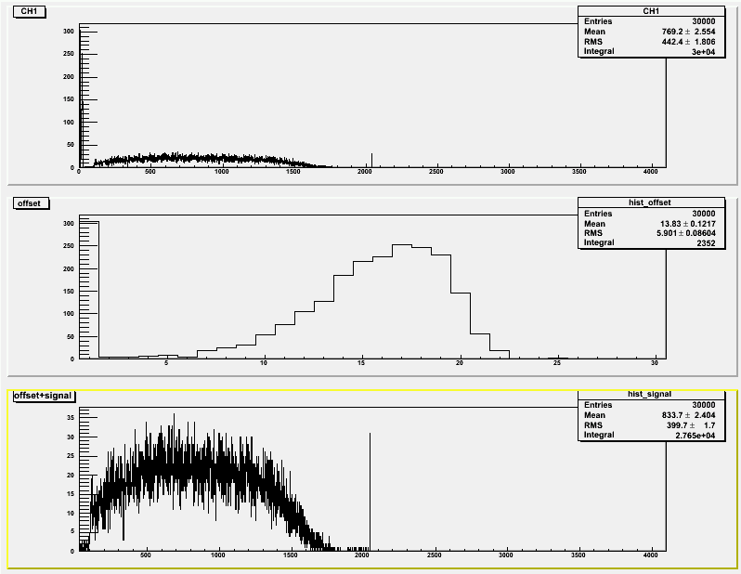

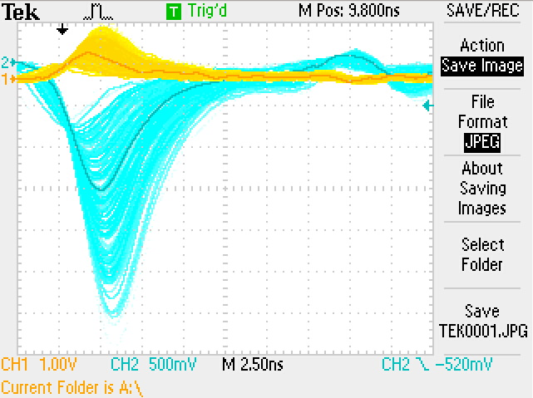

Integrated charge spectrum and oscilloscope snapshot at 1700V

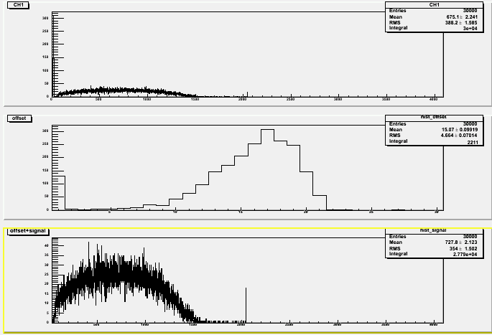

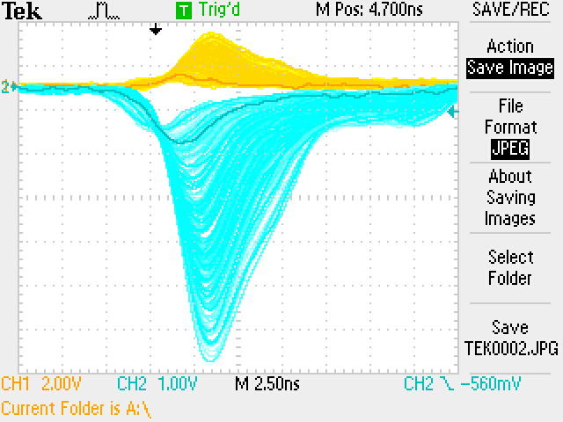

Integrated charge spectrum and oscilloscope snapshot at 1425V

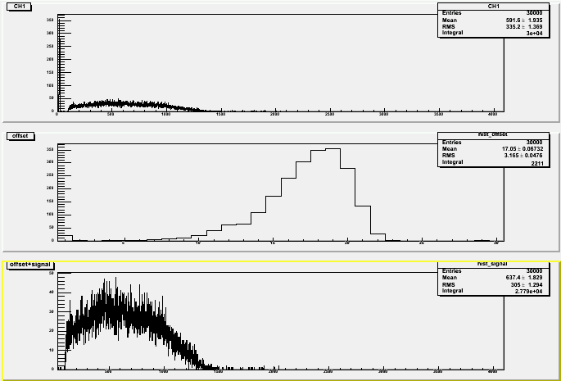

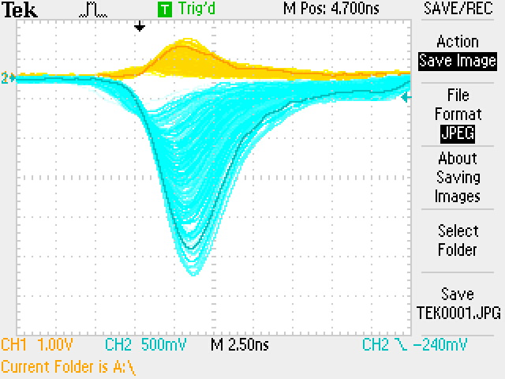

Dark current at 1700V, 1500V, and 1425V

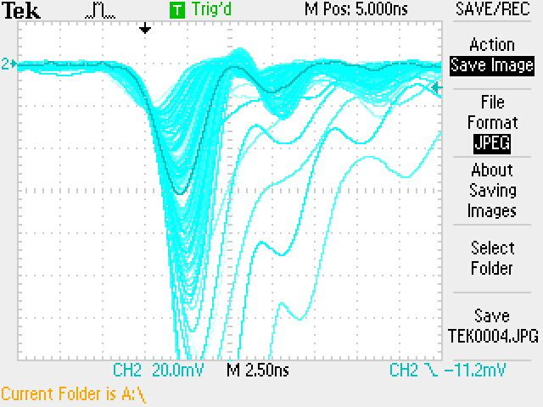

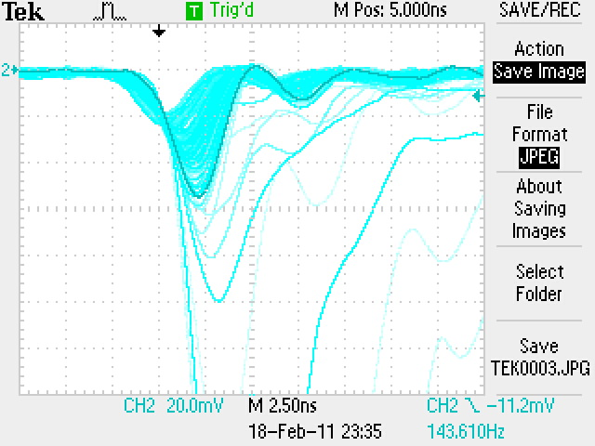

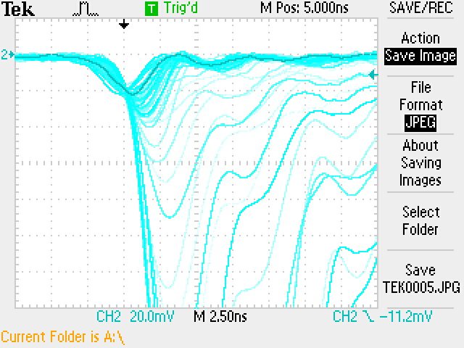

**FA0281**

Integrated charge spectrum and oscilloscope snapshot at 1700V

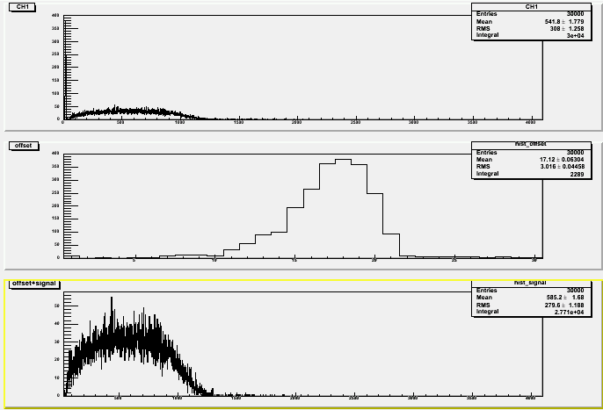

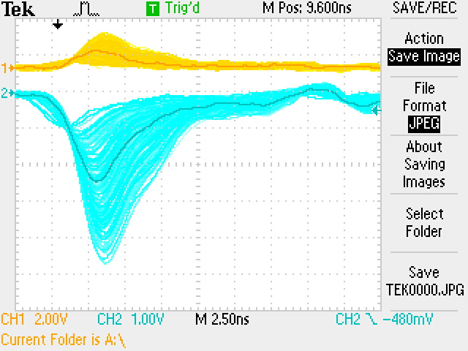

Integrated charge spectrum and oscilloscope snapshot at 1500V

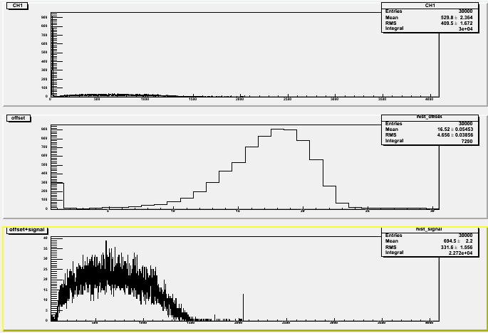

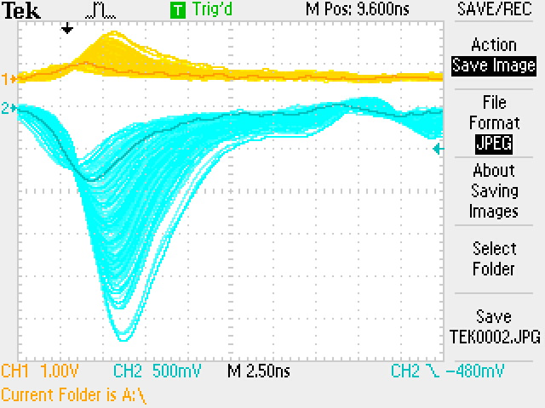

Integrated charge spectrum and oscilloscope snapshot at 1475V

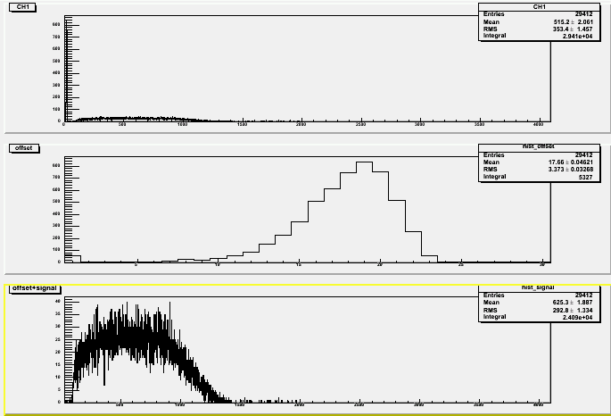

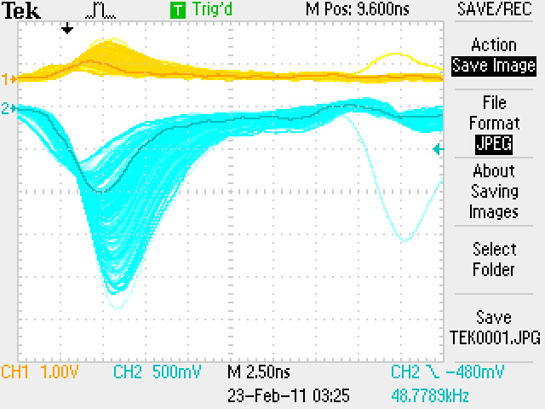

Dark current at 1700V and 1500V

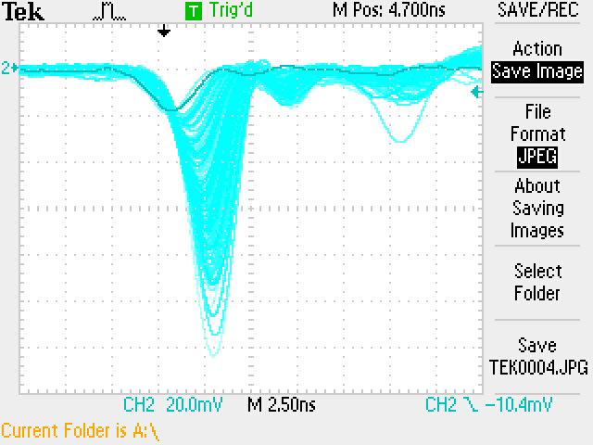

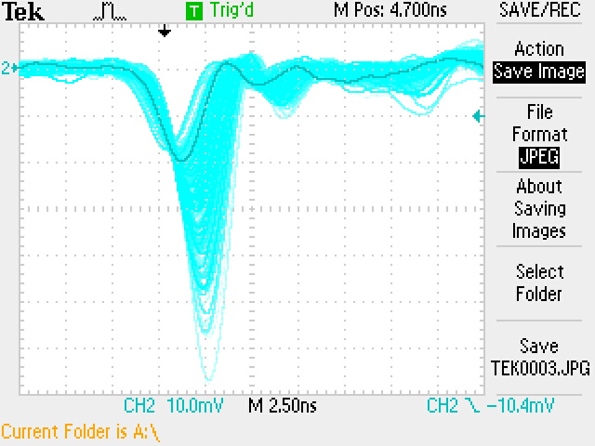

**FA0220**

Integrated charge spectrum and oscilloscope snapshot at 1700V

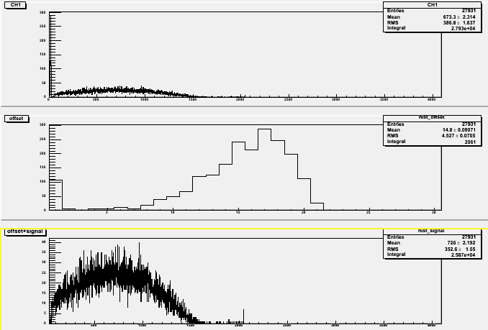

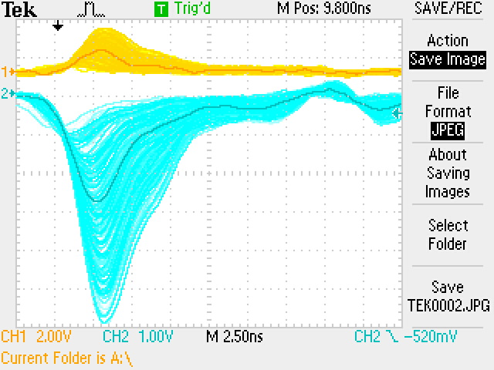

Integrated charge spectrum and oscilloscope snapshot at 1500V

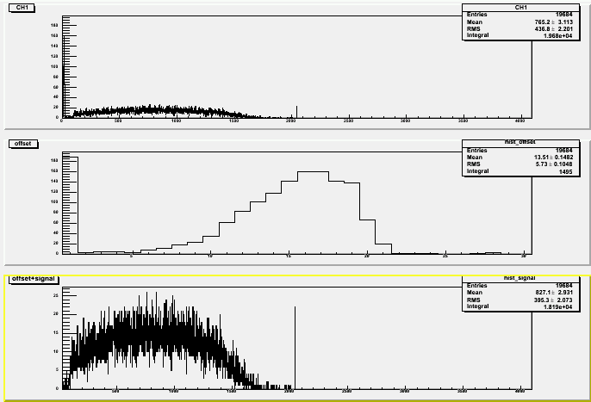

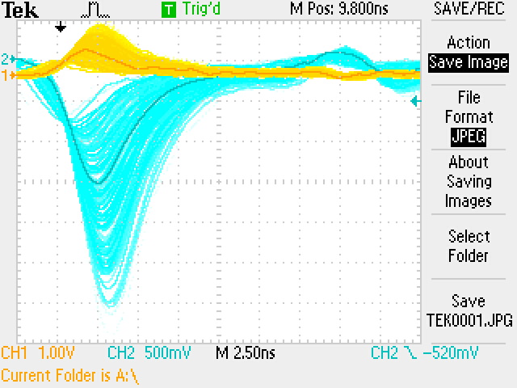

Integrated charge spectrum and oscilloscope snapshot at 1425V

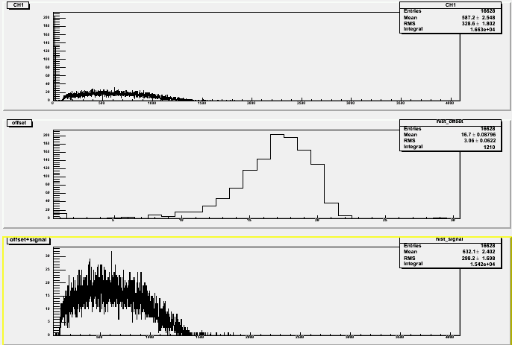

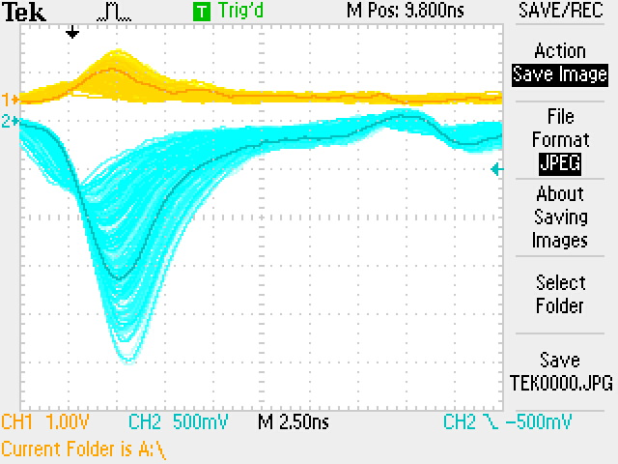

Dark current at 1700V and 1500V

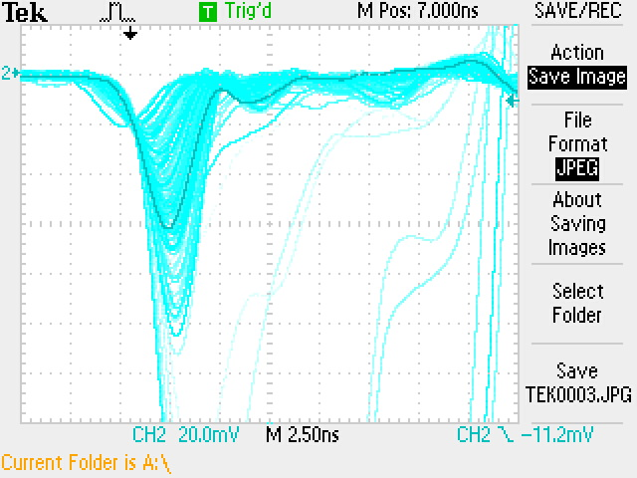

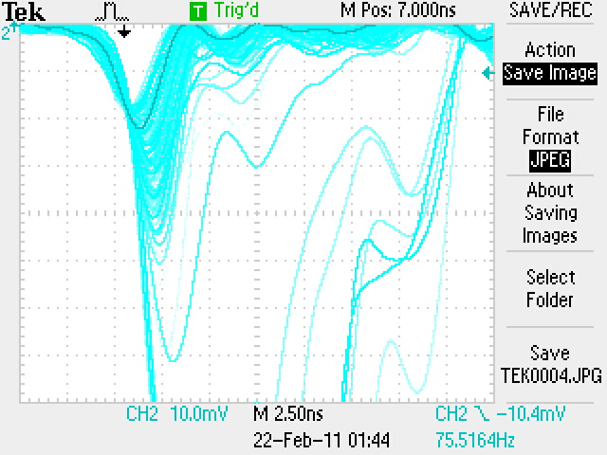

**FA0425**

Integrated charge spectrum and oscilloscope snapshot at 1700V

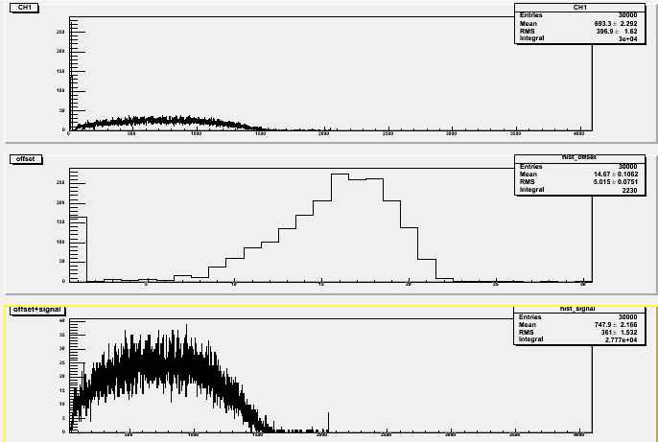

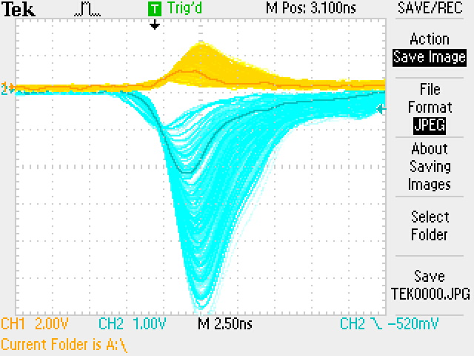

Integrated charge spectrum and oscilloscope snapshot at 1500V

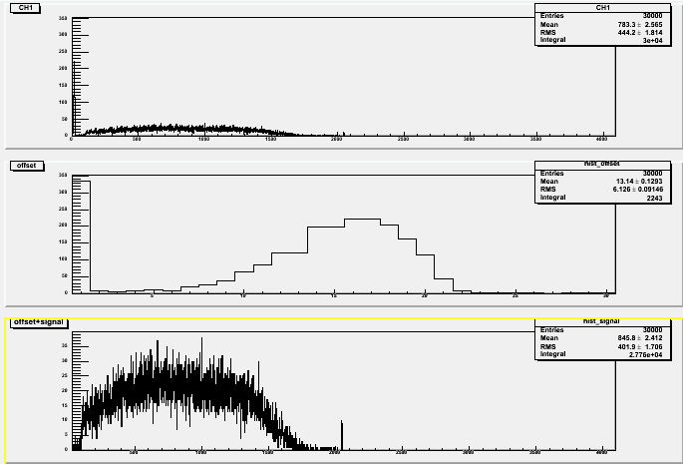

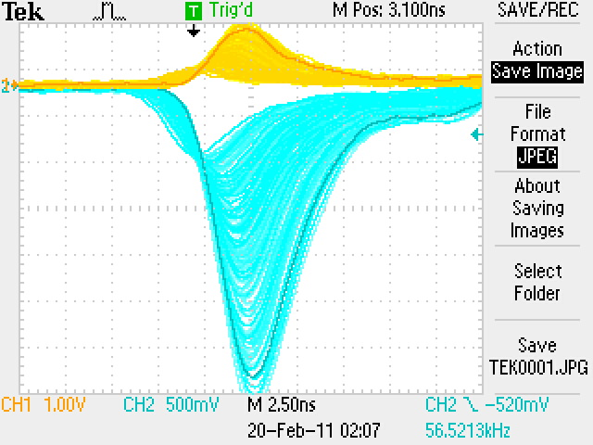

Integrated charge spectrum and oscilloscope snapshot at 1425V

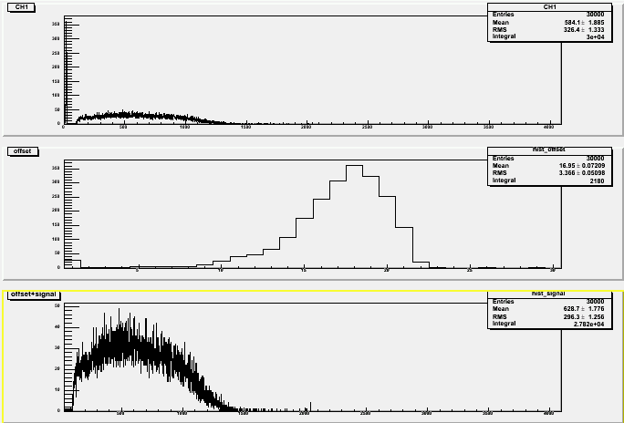

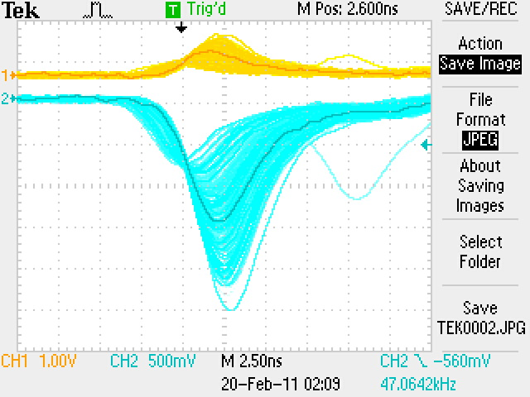

Dark current at 1700V, 1500V, and 1425V

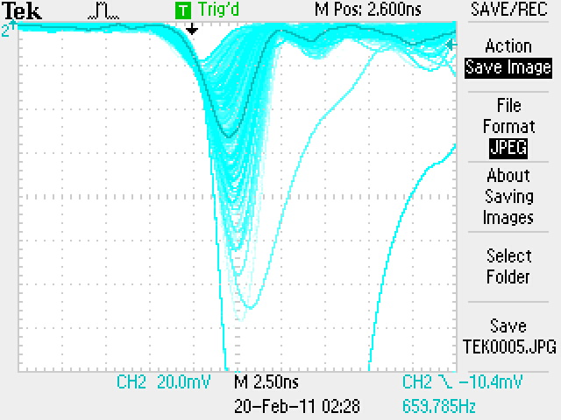

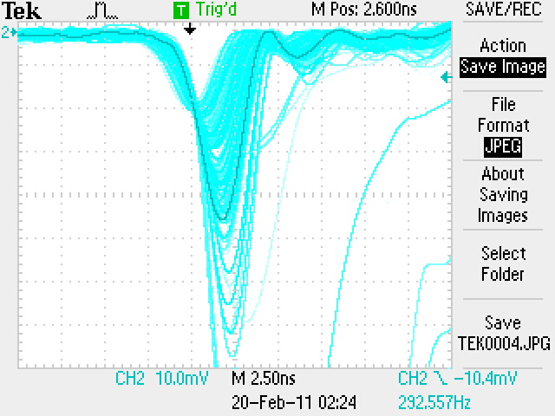

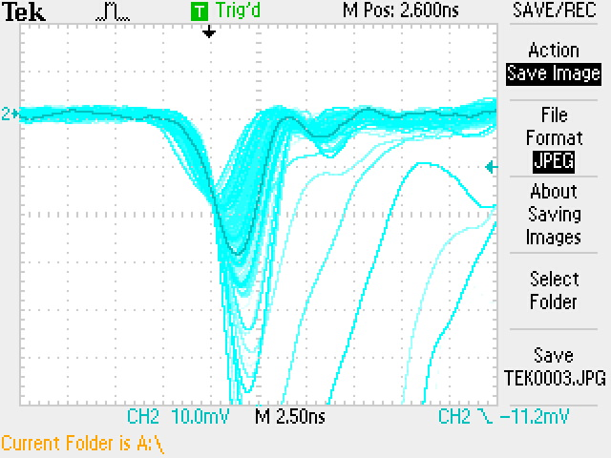

**FA0293**

Integrated charge spectrum and oscilloscope snapshot at 1700V

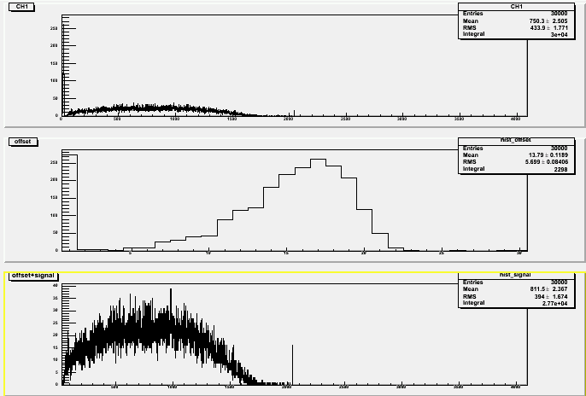

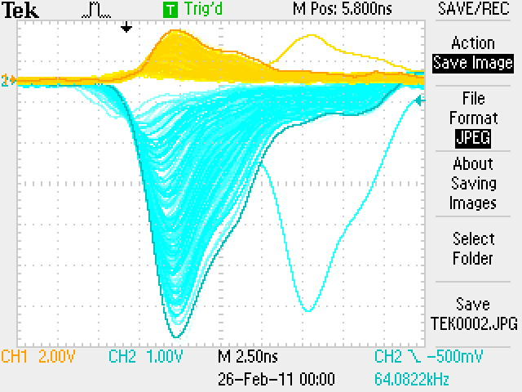

Integrated charge spectrum and oscilloscope snapshot at 1500V

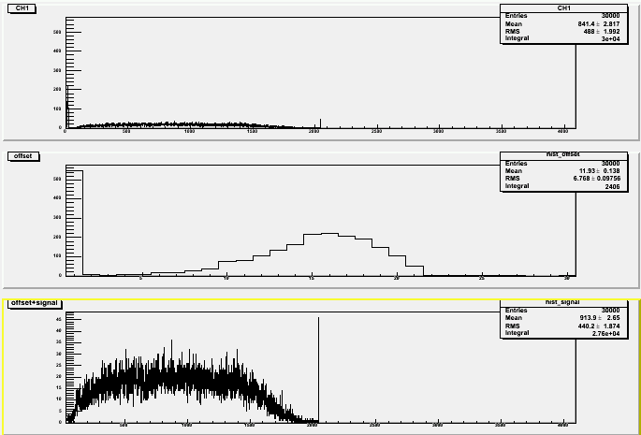

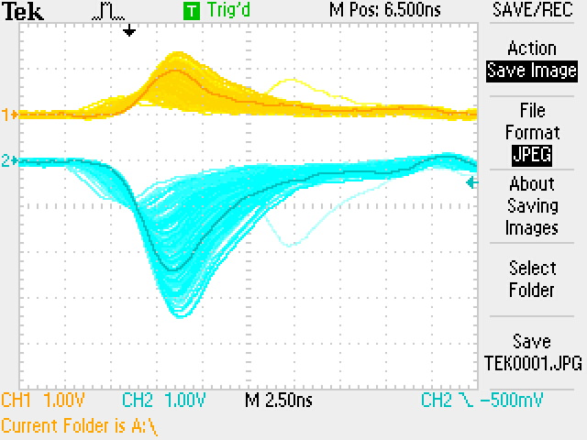

Integrated charge spectrum and oscilloscope snapshot at 1375V

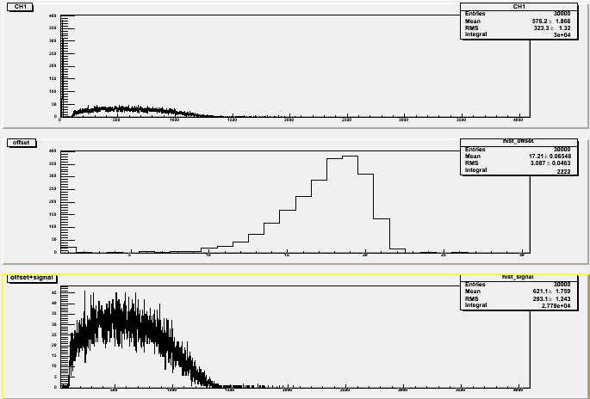

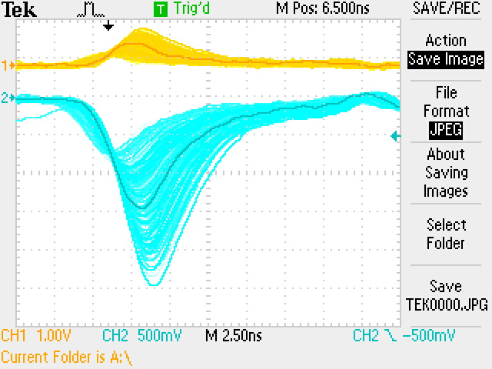

Dark current at 1700V, 1500V, and 1375V

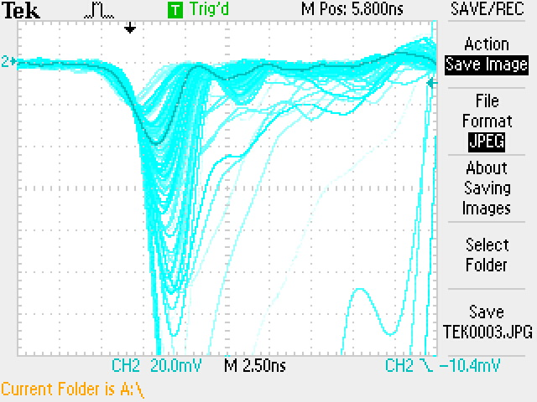

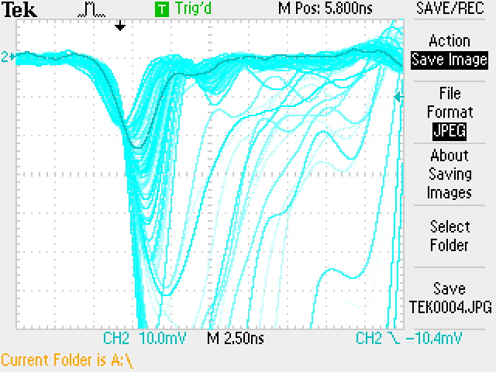

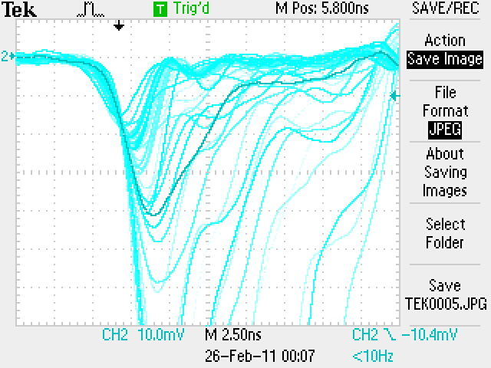

**FA0295**

Integrated charge spectrum and oscilloscope snapshot at 1700V

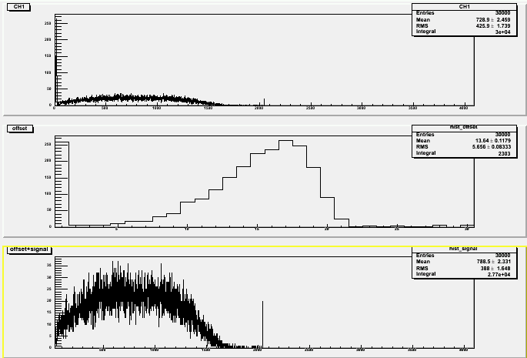

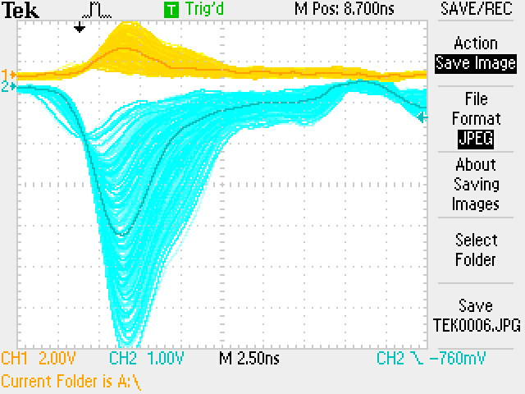

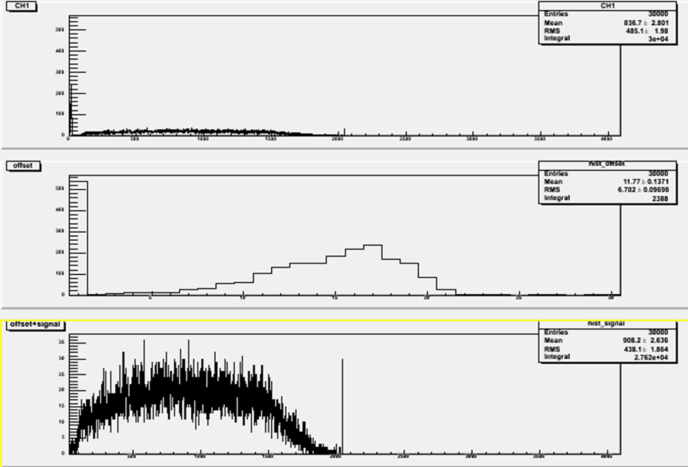Integrated charge spectrum and oscilloscope snapshot at 1500V

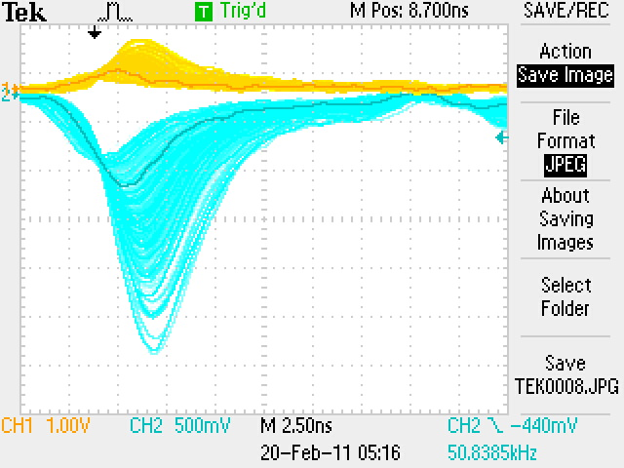

Integrated charge spectrum and oscilloscope snapshot at 1375V

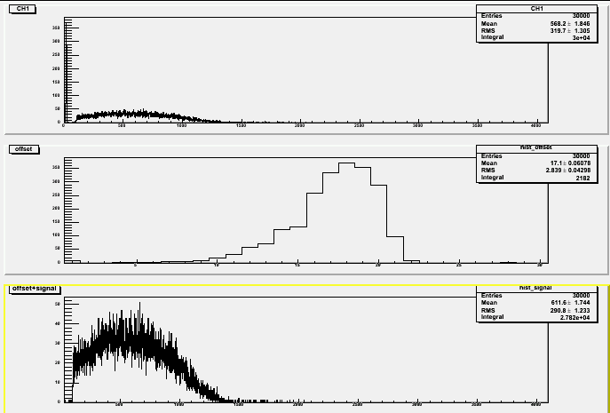

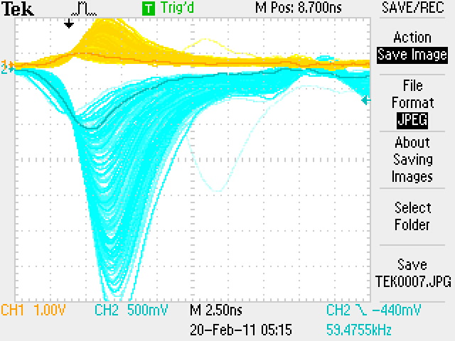

Dark current at 1700V, 1500V, and 1375V

